Attendance:
Krystle Yarber, Holly Kotner, Kristy Wood, Stacia Penrod, Jessica Palazzolo, Megan Ragan, Misty Eftink, Amy Tripp, Megan Johnson, Micah Dodd, Shae Davidson, Rachel Watson, Mel Dotson, Laura Thomas, Leanett Lovell, Tracy Adams, Denis Bourland, Angela Colby-Jackson, Sue Thom, Vicki Rose

Approval of Date Meeting Minutes:
Megan Ragan made motion to approve last month’s meeting minute and Stacia Penrod seconded it. All Aye.

Upcoming Community Events and Trainings:

- Sue Thom
  - Personal Care Assistant Training January 29, 2026 from 1-3p
- Stacia Penrod
  - Triple P Parenting starts Jan 14th for 6 weeks from 830-10am. This is a hybrid model, offering in person classes at the Carmi office or via ZOOM. Cost is $35.00 and this covers the book & class. Please contact Krystle Yarber to sign up.
- Melinda Dotson
  - PACE meeting, January 27th @ the iHUB from 530-7p
- Angela Colby-Jackson & Megan Ragan
  - Parenting class “Nurturing Parent Program” via ZOOM
  - BRICK Sidekick via ZOOM
  - Clinicians Training January 16

Goals/Needs:
- If there are any families or clients in need, please refer to us @ EHD!
- Bring More people to LAN
- In-Person Meeting for Spring 2026

Presentation:
- January 2026
  - Megan Ragan – SIRAC, please see below for presentation slides.
- February
  - No Presenter

If you would like to do a presentation, please contact Krystle Yarber @ kyarber@egyptian.org

Adjournment:
Stacia Penrod Motioned to adjourn. All Ayed!

**To view the meeting minutes please go to https://www.localareanetwork2.org/ **
Our next monthly meeting will be February 3, 2026 @ 9:00am.
***The ZOOM link is provided below. ***

Join Zoom Meeting
https://us02web.zoom.us/j/6018470310
Meeting ID: 601 847 0310
Password: 04032629
One tap mobile
+13126266799,,6018470310#,,1#,04032629# US (Chicago)
+13017158592,,6018470310#,,1#,04032629# US (Germantown)
Dial by your location
+1 312 626 6799 US (Chicago)
+1 301 715 8592 US (Germantown)
+1 646 558 8656 US (New York)
+1 253 215 8782 US (Tacoma)
+1 346 248 7799 US (Houston)
+1 669 900 9128 US (San Jose)
Meeting ID: 601 847 0310
Password: 04032629
Find your local number: https://us02web.zoom.us/u/keAHO54Ih2
*** If anyone has any flyers or information that you would like to have sent out in the LAN e-mail announcement or would like to present, please send them to Krystle Yarber at kyarber@egyptian.org by the third Monday of the month. ***
Minutes by Krystle Yarber
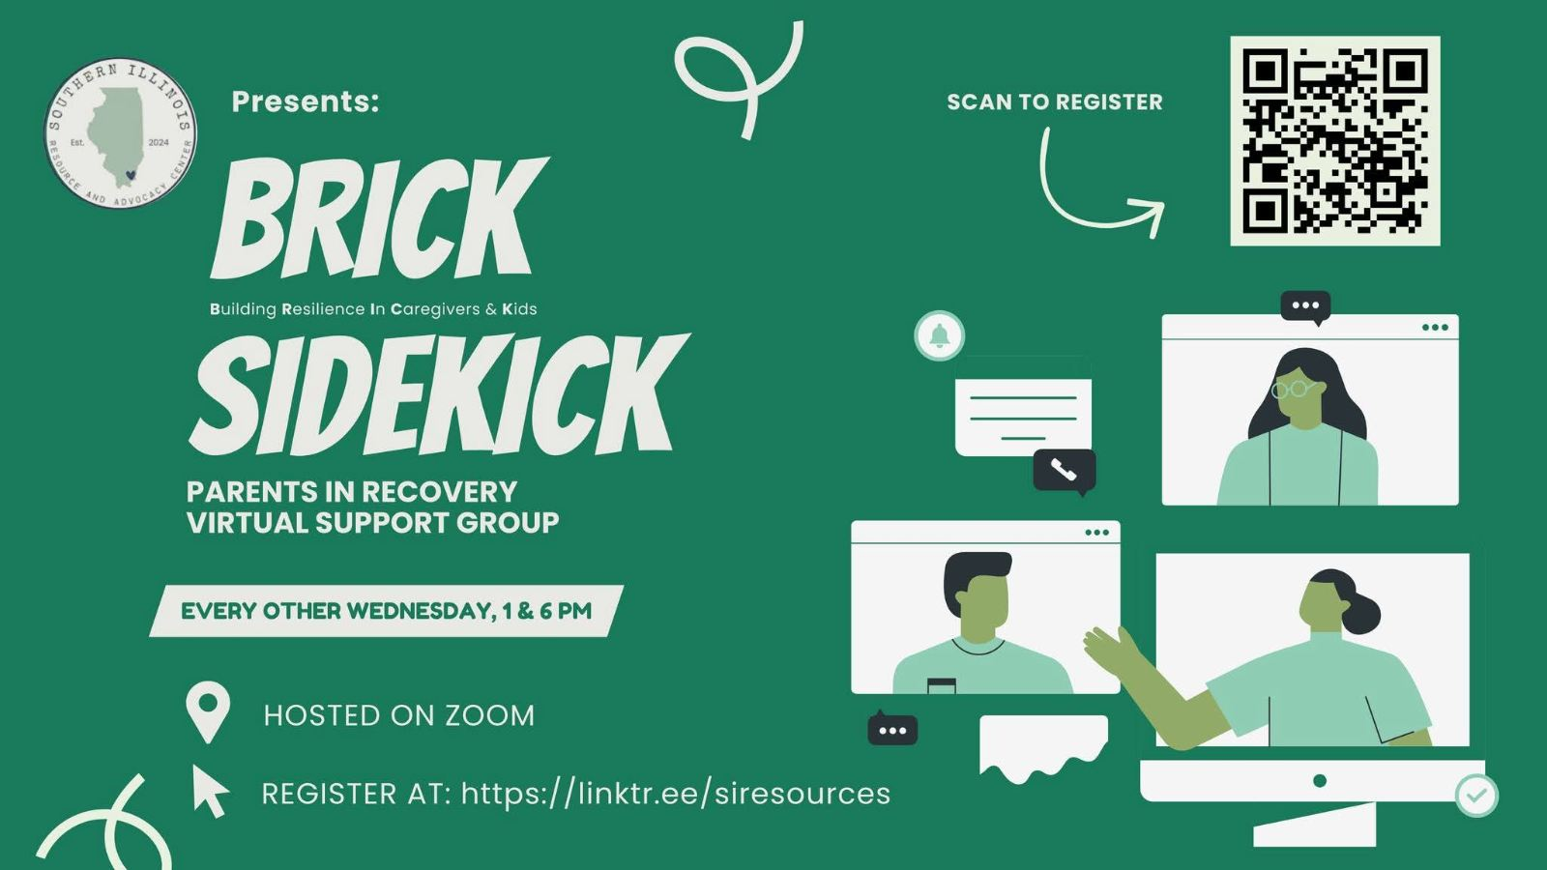
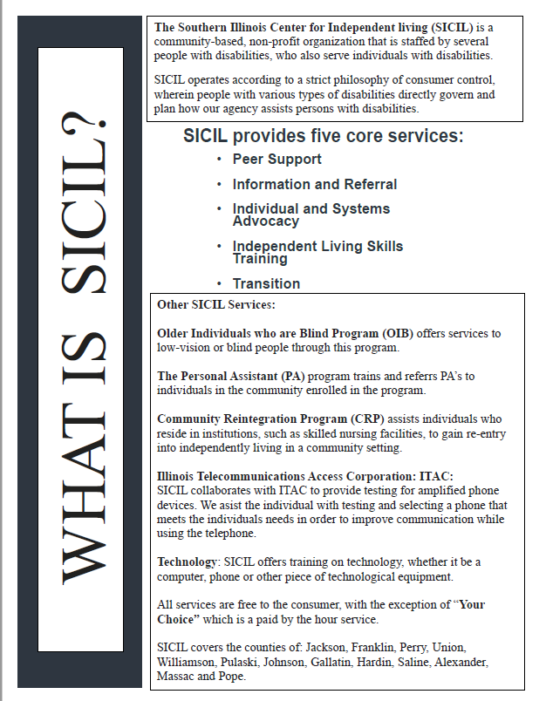
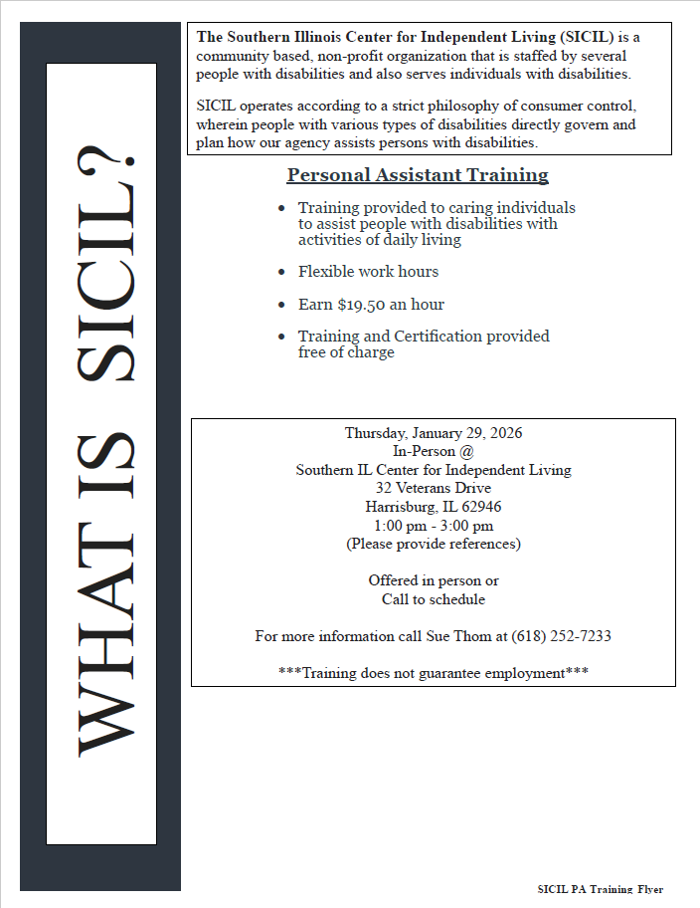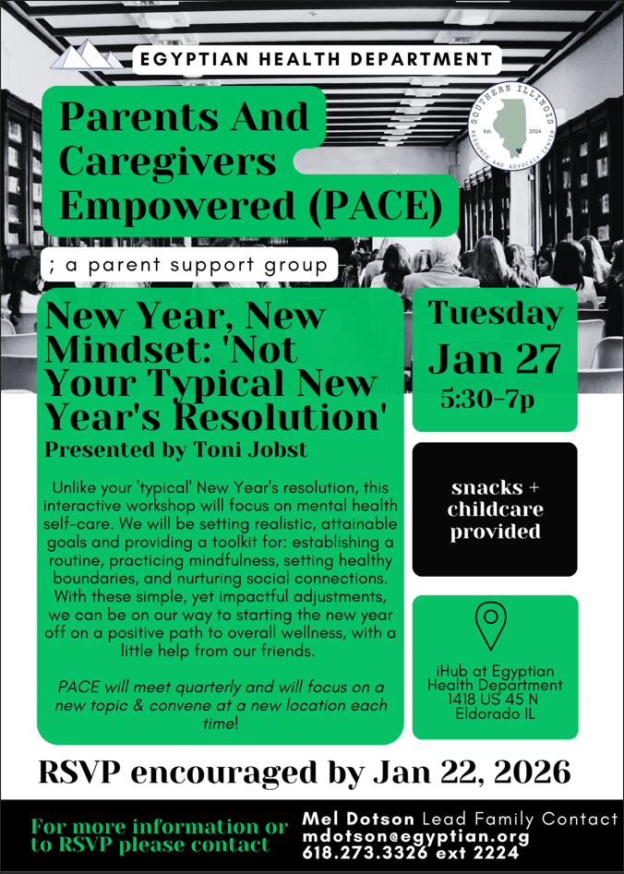

SIRAC Presentation Slides (10):