Attendance:
Krystle Yarber, Holly Kotner, Kristy Wood, Stacia Penrod, Jessica Palazzolo, Megan Ragan, Lynn Penrod, Misty Eftink, Amy Tripp, Megan Johnson, Micah Dodd

Approval of Date Meeting Minutes:
Kristy Wood made motion to approve last month’s meeting minute and Holly Kotner seconded it. All Aye.

Upcoming Community Events and Trainings:

- Stacia Penrod
  - SI Suprt QR Code, if you have not taken the survey, please do so by scanning the QR code!
  - Suicide Prevention Taskforce, currently made a recent change in their meeting days & times. They will meet Quarterly starting on Thursday, Feb. 5, 2026 @ 2pm. If you would like to join or know anyone who would like to join, please contact Krystle Yarber @ kyarber@egyptian.org to get put on the email list!
  - PACE meeting – More to Come
- Krystle Yarber
  - Sharing on behalf of Southern Illinois Center for Independent Living Flyer
    - They have their personal Assistant Training coming up on Dec. 18, 2025 @ 1-3p. If you know anyone who would like to attend, please have them contact Sue Thom.
- Jessica Palazolo
  - Free Training on ZOOM 12/17/2025 11:30a-12:30p CST
    - Let’s Chat: Kid’s, Games, & Technology
- Megan Ragan
  - Respite
    - Pre-registration is REQUIRED (scan the QR code on the flyer to sign up!). https://forms.gle/8fZL5stkoWNRd4nq9
  - Operation Stock the Snacks is BACK! We are so glad to be able to provide our local schools with some yummy snacks for the children again.
This year we are asking that each school interested in receiving snacks fills out the form below. This will help us to keep better track of which schools are wanting snacks and how much is needed! We will distribute snacks weekly, in the order in which they were requested. Pick up is at our Shawneetown office, the address is 193 W. Shawnee Ave, Shawneetown.
  - Snack sign up below:
https://docs.google.com/forms/d/e/1FAIpQLSdf1DObRiZOIkyrqbIvUNZoMnyl-3kF3refQgdgOILRZzndw/viewform?fbclid=IwY2xjawOb5ItleHRuA2FlbQIxMABicmlkETFrQTBwdENSTUpEbFZKTDlWc3J0YwZhcHBfaWQQMjIyMDM5MTc4ODIwMDg5MgABHuaOTbmJBZZ3PLLvWiNTnCqa2jIQda_BFZcnmiiYUTJUw649T6YI0lWq6pJL_aem_sf-2diTzBHMJcwzmG_9Hnw

Goals/Needs:
- If there are any families or clients in need, please refer to us @ EHD!
- Bring More people to LAN
- In-Person Meeting
  - Spring or Fall

Presentation:
- December 2025
  - No Presenter

- January 2026
  - Megan Ragan - SIRAC

If you would like to do a presentation, please contact Krystle Yarber @ kyarber@egyptian.org

Adjournment:
Stacia Penrod Motioned to adjourn. All Ayed!

**To view the meeting minutes please go to https://www.localareanetwork2.org/ **
Our next monthly meeting will be January 6, 2026 @ 9:00am.
***The ZOOM link is provided below. ***

Join Zoom Meeting
https://us02web.zoom.us/j/6018470310
Meeting ID: 601 847 0310
Password: 04032629
One tap mobile
+13126266799,,6018470310#,,1#,04032629# US (Chicago)
+13017158592,,6018470310#,,1#,04032629# US (Germantown)
Dial by your location
+1 312 626 6799 US (Chicago)
+1 301 715 8592 US (Germantown)
+1 646 558 8656 US (New York)
+1 253 215 8782 US (Tacoma)
+1 346 248 7799 US (Houston)
+1 669 900 9128 US (San Jose)
Meeting ID: 601 847 0310
Password: 04032629
Find your local number: https://us02web.zoom.us/u/keAHO54Ih2
*** If anyone has any flyers or information that you would like to have sent out in the LAN e-mail announcement or would like to present, please send them to Krystle Yarber at kyarber@egyptian.org by the third Monday of the month. ***
Minutes by Krystle Yarber
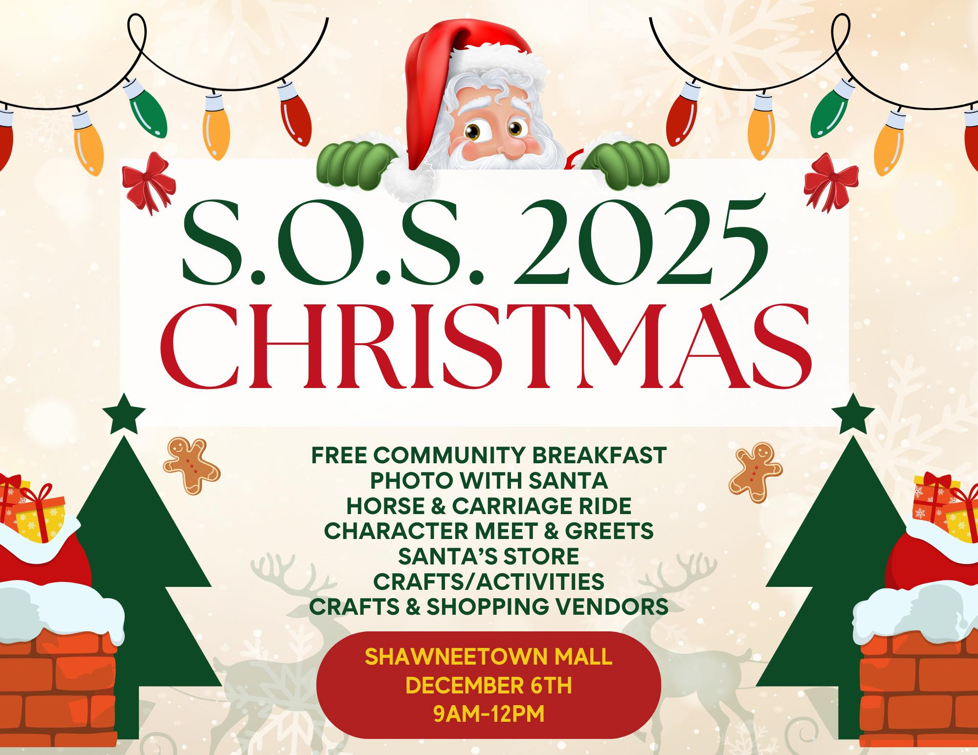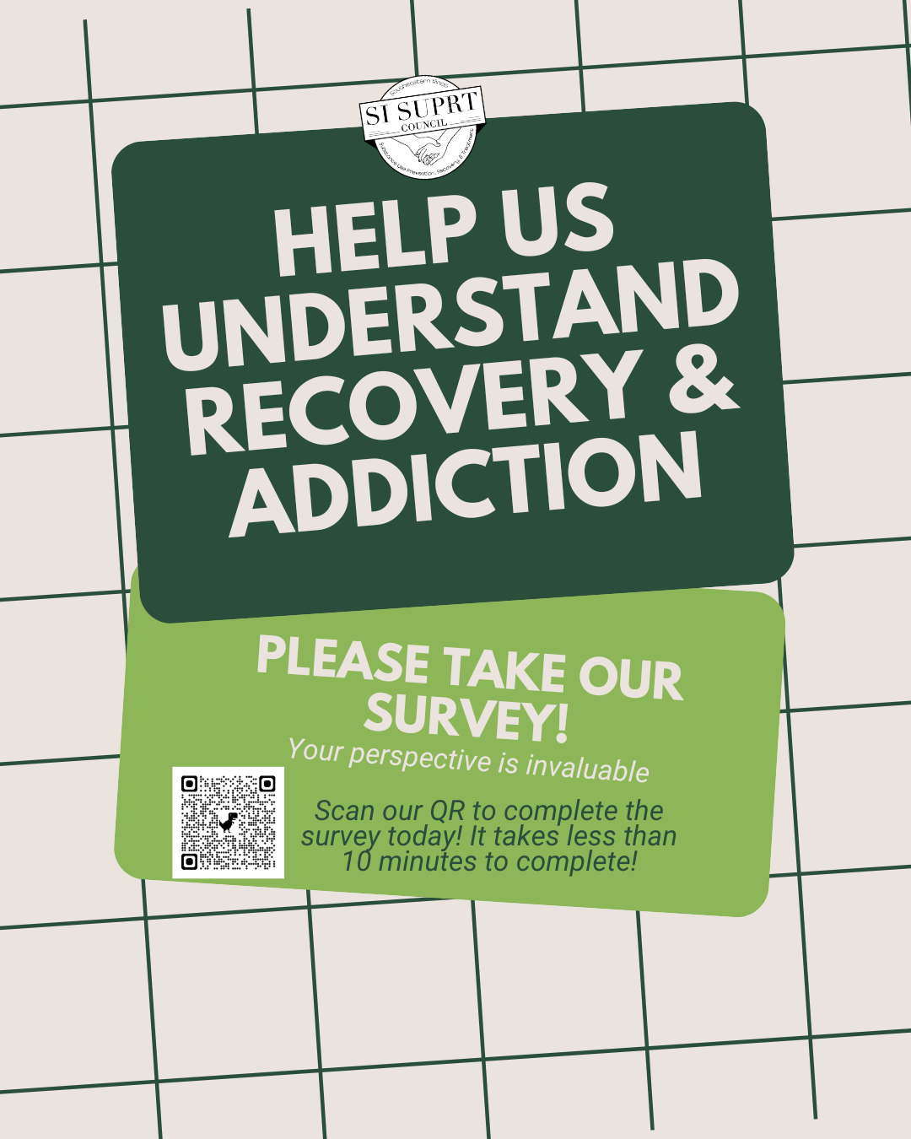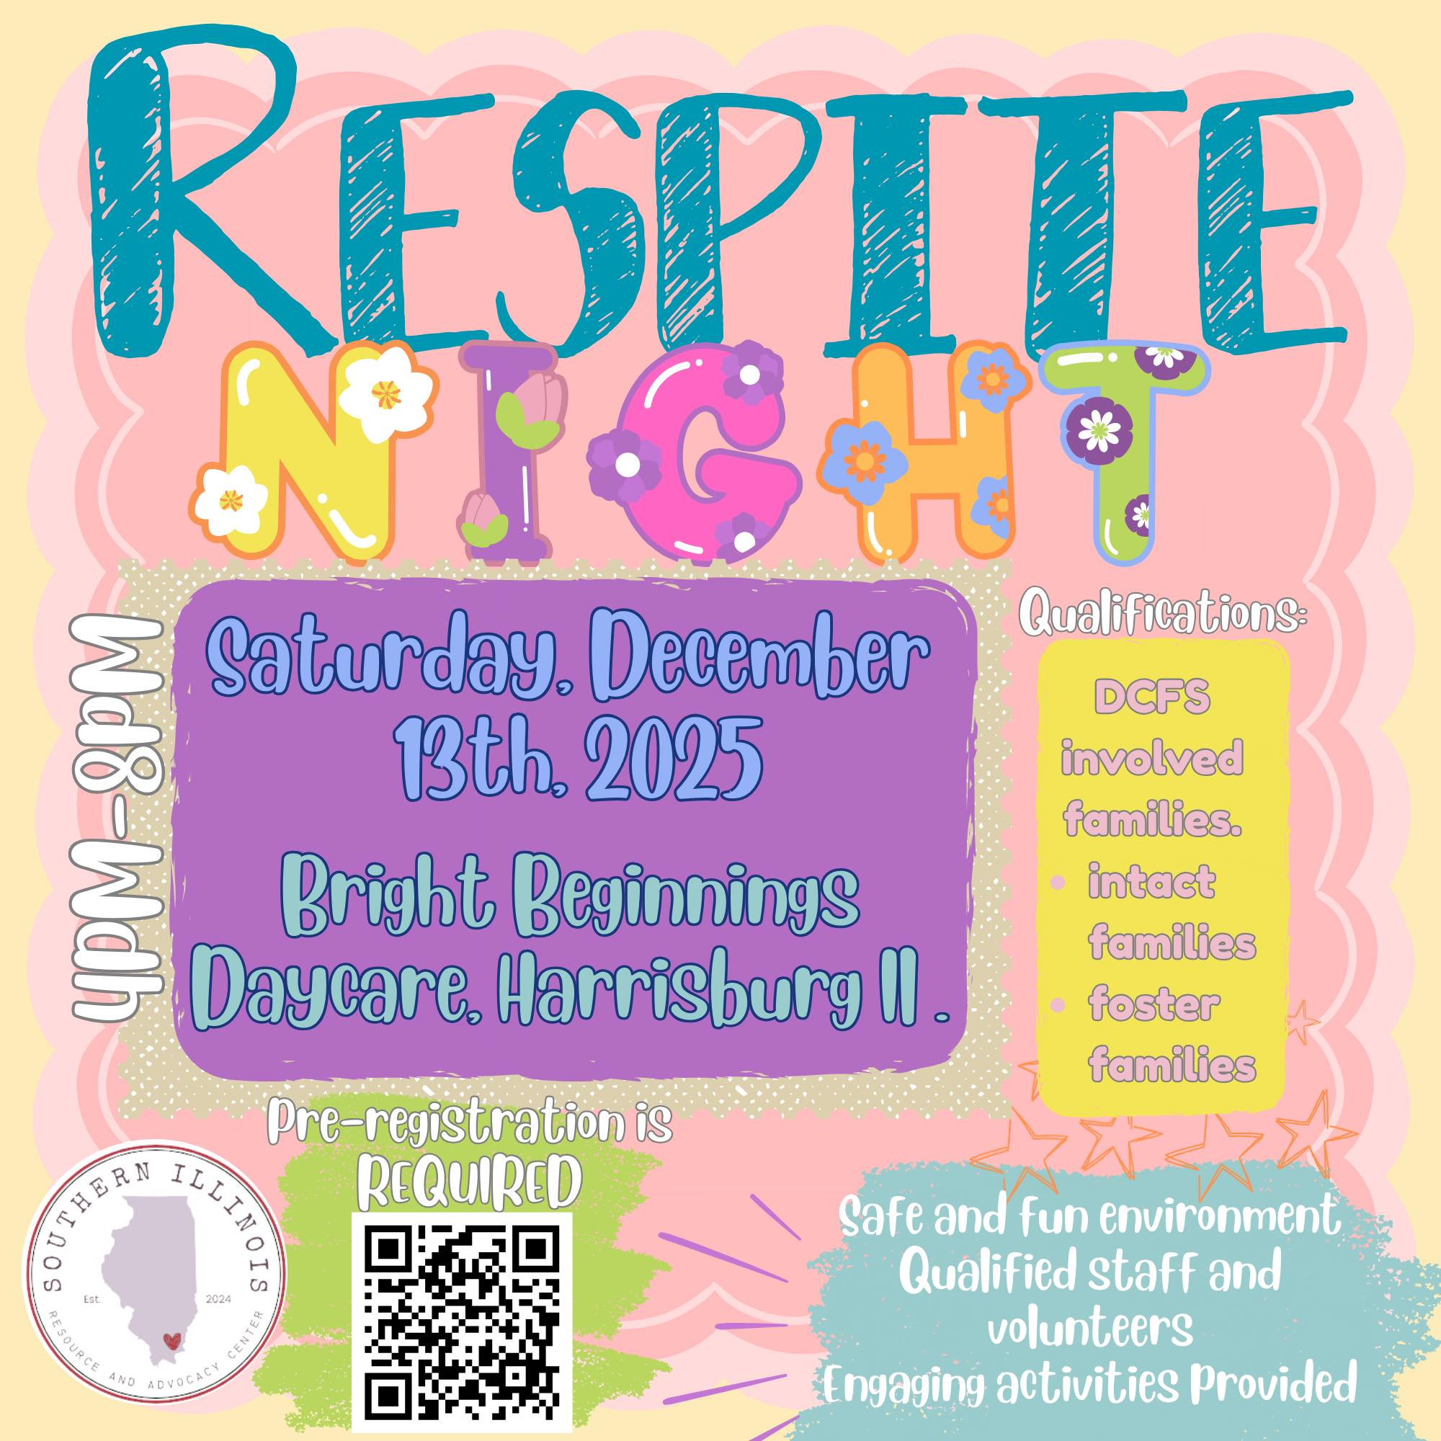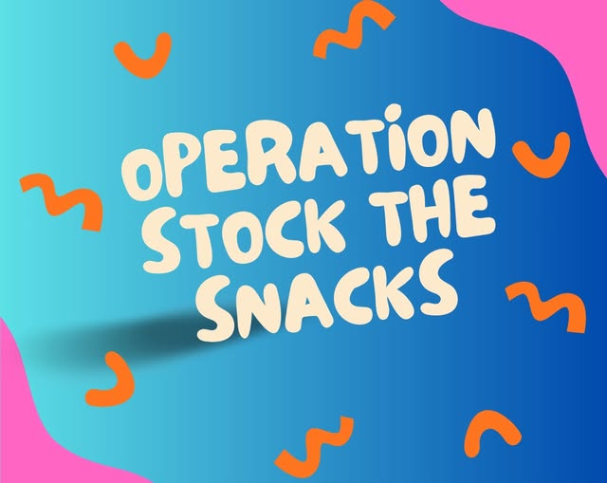

Snack sign up below:
https://docs.google.com/forms/d/e/1FAIpQLSdf1DObRiZOIkyrqbIvUNZoMnyl-3kF3refQgdgOILRZzndw/viewform?fbclid=IwY2xjawOb5ItleHRuA2FlbQIxMABicmlkETFrQTBwdENSTUpEbFZKTDlWc3J0YwZhcHBfaWQQMjIyMDM5MTc4ODIwMDg5MgABHuaOTbmJBZZ3PLLvWiNTnCqa2jIQda_BFZcnmiiYUTJUw649T6YI0lWq6pJL_aem_sf-2diTzBHMJcwzmG_9Hnw

