**MINUTES OF THE LOCAL ARE NETWORK 2**

**STEERING COMMITTEE MEETING**

**Date: November 5, 2024**

**Present:** Rachel W., Hannah Jude, Krystle Yarber, Stacia Penrod, Holly Kotner, Kristy Wood, Jason Robershaw, Sue Thom, Kristin Stewart, Tonya Hardy, Vickie Rose, Tricia Harrison, Matt Buckman, Lori Clendenin, Tracy Adams, Misty Eftink, Lindsay Schroeder,

**Welcome/Introductions:** Jason Robershaw welcomed everyone to the meeting and introductions were made.

**Approval of Date Meeting Minutes:** Jason Robershaw went over last month meeting minutes. Stacia Penrod made motion to approve last month’s meeting minute and Tonya Hardy seconded it. All Aye.

**Updates:**

* **Tonya Hardy** 
  + Finished up SUDS & SMILES Oct. 26th
    - If you have anything to donate, please contact Tonya
  + November 21st PACE Christmas event @ Eldorado HS Cafeteria from 530-7, If you would like a table, please contact Tonya
    - *Santa will be in the building*
  + Angel Tree details to come!
* **Vickie Rose & Sue Thom** 
  + Individuals that need home modifications, due to disability, please contact Vickie or Sue @ the Center for Independent living
  + Trying to get bids from local contractors to help
* **Holly Kotner**
  + Helped w/SUDS & Smiles
  + Free Dental Services @ Carmi Family Dental, did not get to go, but did make 100 packets with EHD & INCK Resources
  + Eldorado Elementary is having fall festival
    - FRDs, Tonya & Kristy, CATCH & InCK will be there
  + Dickens of a Christmas coming up Dec. 7th & 8th
    - Breakfast w/ Santa @ the community center
      * Kids get to go to the “Kids for good” and pick out a Christmas gift for themselves & 2 gifts for 2 other people.
      * Sunday the 8th, EHD & InCK will be there serving hot chocolate & letters to Santa and other business will be there. Starts @ noon
* **Stacia Penrod**
  + Project Connect 4.0 overview coming up next month
  + Support Deck services has been moved to the EHD downtown location.  The new address is **946 4th Street, Eldorado**, **Phone Number 618-297-9380.**
* **Jason Robershaw**
  + Lincoln Prairie offering trainings
  + Suicide Prevention Meeting is on the 3rd Tuesday of each month @ 3pm in the Eldorado EHD Large Conference Room.
    - This is for anyone to come & join
    - Currently reaching out to Farmers, Wabash Valley FS, this is an area that has a higher risk of Suicide
    - Suicide Prevention with the upward bound program @ SIC on Nov. 9th @ 10am
  + “Trauma Informed Care” with CASA on Nov. 13th
* **Rachel W. – Harrisburg WADI Home Based Head Start**
  + We have 157 kids enrolled in early head start out of 7 counties, currently our Grant is for 244 kids
  + Still taking applications for enrollment
  + LIHEAP is now Open to all public and booking out until January
  + Housing, do not have any means to help with hotel stay
* **Lindsay – Knight Sheild**
  + Openings on the adult side 18-23

**Resources:**

* **Tonya Hardy -** [thardy@egyptian.org](mailto:thardy@egyptian.org)

**Family Resource Program Manager**

**1412 US Hwy 45 N., Eldorado, IL. 62930**

**PH:(618) 273-3326 Ext 2006**

* **Jason Robershaw –** [**jrobershaw@egyptian.org**](mailto:jrobershaw@egyptian.org)

**Clinical Director for Project Connect 3.0**

**Egyptian Health Department**

**1412 US Hwy. 45 N.**

**Eldorado IL., 62930**

**(618) 273-3326 ext. 2126**

**Fax: (618) 273-2808**

* **Jessica Palazzolo –** [**Jessica.Palazzolo@uhsinc.com**](mailto:Jessica.Palazzolo@uhsinc.com)

**Lincoln Prairie Southern Territory Manager, Business Development**

**Cell (618) 292-9742**

**Goals/Needs:**

* Bring more agencies to the LAN meetings
* Bring More people & Resources to the meeting
* Suicide Task Force Working on Goody bags & Resource to the Farmers

**Upcoming Community Events and Trainings:**

* Suicide Prevention Meeting is on the 3rd Tuesday of each month @ 3pm in the Eldorado EHD Large Conference Room.
* Jason Robershaw will be doing “Suicide Prevention” with the upward bound program @ SIC on Nov. 9th @ 10am
* Jason Robershaw will be doing “Trauma Informed Care” with CASA on Nov. 13th
* November 21st PACE event @ Eldorado HS Cafeteria from 530-7

**Presentations:** Tricia Harrison & Hannah Jude – CATCH

Misty Eftink – INCKY

**Presentation for December 3rd:** Kathryn Bangs – Overview of Parent Guidance

**Adjournment:** Tonya Hardy Motioned to adjourn and Tricia Harrison seconded.

**\*\*To view the meeting minutes please go to** [**https://www.localareanetwork2.org/**](https://www.localareanetwork2.org/) **\*\***

*** The next meeting is scheduled for **Dec. 3rd, 2024 @ 9am.** This will be by zoom**.** The ZOOM link is provided below. ***

**Join Zoom Meeting**[**https://us02web.zoom.us/j/6018470310**](https://us02web.zoom.us/j/6018470310)

**Meeting ID: 601 847 0310  
Password: 04032629  
One tap mobile  
+13126266799,,6018470310#,,1#,04032629# US (Chicago)  
+13017158592,,6018470310#,,1#,04032629# US (Germantown)**

Dial by your location  
        +1 312 626 6799 US (Chicago)  
        +1 301 715 8592 US (Germantown)  
        +1 646 558 8656 US (New York)  
        +1 253 215 8782 US (Tacoma)  
        +1 346 248 7799 US (Houston)  
        +1 669 900 9128 US (San Jose)  
Meeting ID: 601 847 0310  
Password: 04032629  
Find your local number: <https://us02web.zoom.us/u/keAHO54Ih2>

*** If anyone has any flyers or information that you would like to have sent out in the LAN e-mail announcement or would like to present, please send them to Krystle Yarber at [kyarber@egyptian.org](mailto:kyarber@egyptian.org) by the third Monday of the month. ***

*Minutes by Krystle Yarber*

**

**

**

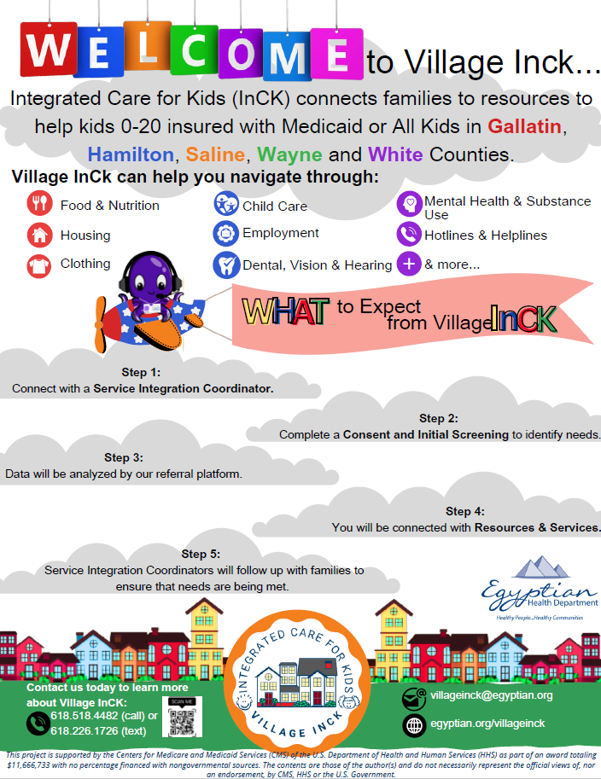

<https://www.canva.com/design/DAF6W-UxSsc/uxVrS2dF_CfNAGL7U40RHw/watch?utm_content=DAF6W-UxSsc&utm_campaign=designshare&utm_medium=link&utm_source=editor>

**

**

**