LOCAL ARE NETWORK 2
Date: April 1, 2025

Welcome/Introductions:
Jason Robershaw welcomed everyone to the meeting and introductions were made.

Approval of Date Meeting Minutes:
Jason Robershaw went over last month meeting minutes. All Ayed.

Updates:
- Mental Health Block Party in May 29th from 330-630 @ Eldorado Downtown, if it rains this will be moved to the Eldorado High School.
  - Sign-up link below:
    - https://docs.google.com/forms/d/e/1FAIpQLSf2h1oILh67bpspwfHKMxqxoPKVNzEC5O7zmy4GfT0FawamBw/viewform?usp=dialog
    - Book Walk
    - Snow Cones
    - Corn Hole
    - U of I: Mobile Kitchen
    - Museum of Mobile Tolerance
    - Popcorn Bags – Suicide Prevention Taskforce
- IMCANS Booster Training – June 12th 9-12 @ iHUB
- WADI LIHEAP is still taking applications
  - Housing for the homeless money is all gone
  - Picture Day is in April

Goals/Needs:
- If there are any families or clients in need, please refer to us @ EHD!
- Bring More people to LAN

Upcoming Community Events and Trainings:
- Lincoln Prairie has Free CEU Training
  - April 10th – Not their Phone 9am
  - May 7^{th – Cognitive Bias 9am}
- June 11 – PANs “Pandas” Training 12:00 – Unresolved Infection in Body
- Suicide Prevention Meeting is on the 3rd Tuesday of each month @ 3pm in the Eldorado EHD Large Conference Room.
- Mental Health Block Party in May 29th from 330-630 @ Eldorado Downtown
- April 22 – Marion CAP Walk

Presentations:

Kristin Gharst -CRSA
CRSA website: https://crsa.illinois.gov/

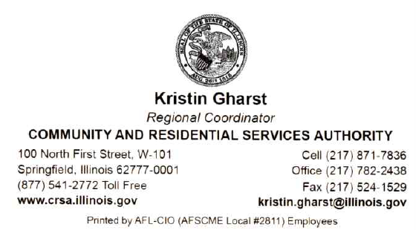

Adjournment:
Jason Robershaw Motioned to adjourn and Holly Kotner seconded. All Ayed!

**To view the meeting minutes please go to https://www.localareanetwork2.org/ **
Our next monthly meeting will be Tuesday, May 6th, 2025 @ 9:00am. The ZOOM link is provided below. ***
Join Zoom Meeting
https://us02web.zoom.us/j/6018470310
Meeting ID: 601 847 0310
Password: 04032629
One tap mobile
+13126266799,,6018470310#,,1#,04032629# US (Chicago)
+13017158592,,6018470310#,,1#,04032629# US (Germantown)
Dial by your location
+1 312 626 6799 US (Chicago)
+1 301 715 8592 US (Germantown)
+1 646 558 8656 US (New York)
+1 253 215 8782 US (Tacoma)
+1 346 248 7799 US (Houston)
+1 669 900 9128 US (San Jose)
Meeting ID: 601 847 0310
Password: 04032629
Find your local number: https://us02web.zoom.us/u/keAHO54Ih2
*** If anyone has any flyers or information that you would like to have sent out in the LAN e-mail announcement or would like to present, please send them to Krystle Yarber at kyarber@egyptian.org by the third Monday of the month. ***
Minutes by Krystle Yarber

