**MINUTES OF THE LOCAL ARE NETWORK 2**

**STEERING COMMITTEE MEETING**

**Date: December 3, 2024**

**Welcome/Introductions:** Jason Robershaw welcomed everyone to the meeting and introductions were made.

**Approval of Date Meeting Minutes:** Jason Robershaw went over last month meeting minutes. Dr. Bangs made motion to approve last month’s meeting minute and Tonya Hardy seconded it. All Aye.

**Updates:**

* **Tonya Hardy**
  + **PACE was a huge success in November with 150-200 people.**
  + **Angel tree has 6 kids left that need a sponsor.**
* **Rachel Chruszczyk**
  + **Free training on 12/10/24 at 10:30am about drug endangered children, contact Rachel to register.**
* **Amy Tripp**
  + **DCFS has recruitment events upcoming**
* **Joyce Schlag**
  + **Spero is hiring, looking for foster care assistant and more.**
* **Kathryn Bangs** 
  + **Presentation on parent guidance and fielded questions.**
* **Shae Davidson**
  + **Survivor empowerment center shared about their operations and resources.**
* **Jason Robershaw**
  + **Lincoln Prairie offering trainings**
  + **Suicide Prevention Meeting is on the 3rd Tuesday of each month @ 3pm in the Eldorado EHD Large Conference Room.** 
    - **This is for anyone to come & join**
  + **Dickens of a Christmas downtown Eldorado up Dec. 7th & 8th**

**Resources/Contacts:**

* **Kristin Gharst**     
  Kristin Gharst Southern Regional Coordinator CRSA (Community and Residential Services Authority) 217-871-7836

[Kristin.gharst@illinois.gov](mailto:Kristin.gharst@illinois.gov)

Website: CRSA <https://crsa.illinois.gov/>

* **Joyce Schlag**  
  Central Intake Coordinator   
  Spero Family Services   
  123 S 10th Street  
  1st Floor  
  Mt Vernon IL 62864  
   [joyce.schlag@sperofs.org](mailto:joyce.schlag@sperofs.org)

618-204-5522 Ext 8223

* **Tonya Hardy**  
  Family Resource Program Manager  
  Egyptian Health Department  
  Project Connect 4.0  
  1412 US Hwy 45 N.  
  Eldorado, IL. 62930  
  PH:(618) 273-3326 Ext 2006  
  FX:(618) 273-2808  
  Cell: (618) 518-1736  
  [thardy@egyptian.org](mailto:thardy@egyptian.org)
* **Vickie Rose**

Southern Illinois Center for Independent Living-Harrisburg Office

* **Misty Eftink**

EHD, Village InCK Model. [meftink@egyptian.org](mailto:meftink@egyptian.org)

* **Jason Robershaw**

618-273-3326 x 2126

* **Rachel Chruszczyk**

Prevent Child Abuse Illinois- [rchruszczyk@pcaillinois.org](mailto:rchruszczyk@pcaillinois.org)

* **Kathryn Bangs, PhD, NCSP, PEL, LPHA**  
  Licensed Psychologist  
  Child & Adolescent Division  
  Egyptian Health Department  
  1412 US Highway 45 North  
  Eldorado, IL 62930  
  Phone: 618-313-2014  
  Fax: 618-273-2808
* **Amy Tripp**

 DCFS Resource & Recruitment.  [amy.tripp@illinois.gov](mailto:amy.tripp@illinois.gov)

* **Shae Davidson**

Survivor Empowerment Center, 618-549-4807, [outreach@empoweringsurvivors.org](mailto:outreach@empoweringsurvivors.org)

* **Lindsay Schroeder**

Program Director for the homeless youth program at The Night's Shield. We serve 11–23-year-olds in the 17 southernmost counties. 618-932-6400 or [lindsay.schroeder@thenightsshield.org](mailto:lindsay.schroeder@thenightsshield.org)

* **Megan Johnson**

EHD, Village InCK [mjohnson@egyptian.org](mailto:mjohnson@egyptian.org)

* **Tricia Harrison**

EHD ICHC Program Specialist (former CATCH program) [tharrison@egyptian.org](mailto:tharrison@egyptian.org)

* **Hannah Jude**   
  ICHC Program Specialist   
  Egyptian Health Department   
  [hjude@egyptian.org](mailto:hjude@egyptian.org)

**Goals/Needs:**

* **Natalie Marvel** - request for any supplies/resources for a family of 5 living in a garage. This includes hygiene products, winter clothes, gloves, coats, food, bed/bedding.
* Ideas to extend LAN outreach to SIRAC and Arrow leaf.

**Upcoming Community Events and Trainings:**

* Suicide Prevention Meeting is on the 3rd Tuesday of each month @ 3pm in the Eldorado EHD Large Conference Room.

**Presentations:** Kathryn Bangs – Overview of Parent Guidance

**Adjournment:** Dr. Bangs Motioned to adjourn and Tonya Hardy seconded.

**\*\*To view the meeting minutes please go to** [**https://www.localareanetwork2.org/**](https://www.localareanetwork2.org/) **\*\***

*** The next meeting is scheduled for **Jan. 7th, 2025 @ 9am.** This will be by zoom**.** The ZOOM link is provided below. ***

**Join Zoom Meeting**[**https://us02web.zoom.us/j/6018470310**](https://us02web.zoom.us/j/6018470310)

**Meeting ID: 601 847 0310  
Password: 04032629  
One tap mobile  
+13126266799,,6018470310#,,1#,04032629# US (Chicago)  
+13017158592,,6018470310#,,1#,04032629# US (Germantown)**

Dial by your location  
        +1 312 626 6799 US (Chicago)  
        +1 301 715 8592 US (Germantown)  
        +1 646 558 8656 US (New York)  
        +1 253 215 8782 US (Tacoma)  
        +1 346 248 7799 US (Houston)  
        +1 669 900 9128 US (San Jose)  
Meeting ID: 601 847 0310  
Password: 04032629  
Find your local number: <https://us02web.zoom.us/u/keAHO54Ih2>

*** If anyone has any flyers or information that you would like to have sent out in the LAN e-mail announcement or would like to present, please send them to Krystle Yarber at [kyarber@egyptian.org](mailto:kyarber@egyptian.org) by the third Monday of the month. ***

*Minutes by Krystle Yarber*

**

**

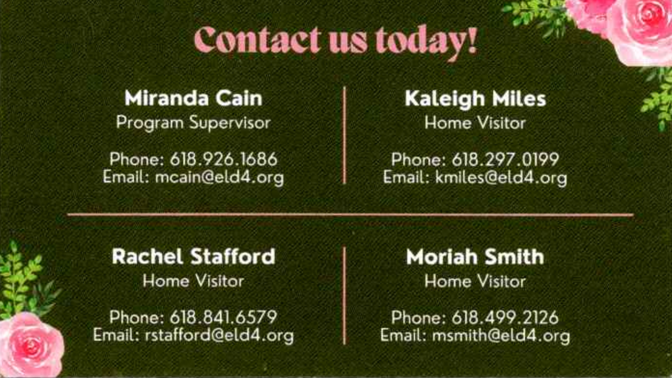

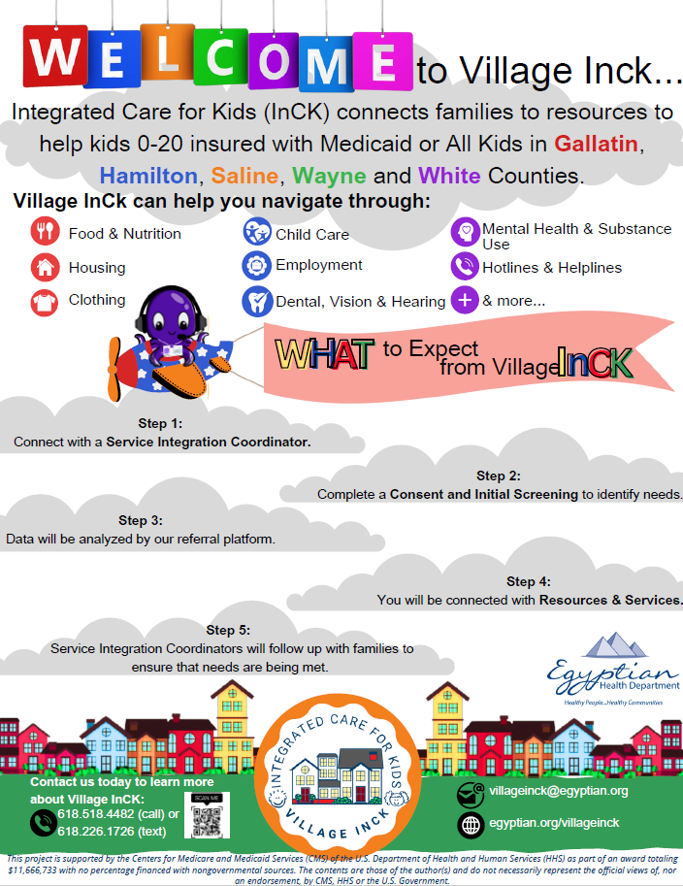

<https://www.canva.com/design/DAF6W-UxSsc/uxVrS2dF_CfNAGL7U40RHw/watch?utm_content=DAF6W-UxSsc&utm_campaign=designshare&utm_medium=link&utm_source=editor>

**

**

**



